

**THE UNIVERSITY OF TEXAS AT**

**ARLINGTON**

**DESIGN AND ANALYSIS OF ALGORITHM**

# **(CSE 5311)**

**PROJECT – 2**

**Project report by:**

1. **Jay Shah**

**Student ID: 1002070975**

1. **Deep Patel**

**Student ID: 1002052935**

* **Sources Referred** 
  1. Geeks for Geeks [(link)](https://www.geeksforgeeks.org/longest-common-subsequence-dp-4/?ref=lbp)
  2. Geeks for Geeks LCS print [(link)](https://www.geeksforgeeks.org/printing-longest-common-subsequence/)
  3. Programiz [(link)](https://www.programiz.com/dsa/longest-common-subsequence)
  4. Python Documentation [(link)](https://docs.python.org/3/library/index.html)
  5. Techie delight [(link)](https://www.techiedelight.com/longest-common-subsequence/)
  6. Lecture Slides

* **Time Complexity of the Algorithm**

|  |  |  |  |
| --- | --- | --- | --- |
| **Algorithm** | **Best** | **Average** | **Worst** |
| LCS_DP_BC(x, y) | Ω(n*m) | θ(n*m) | O(n*m) |
| Printlcs(X, Y, m, n) | Ω(n+m) | θ(n+m) | O(n+m) |

* **Final Output**

**For line 1:**

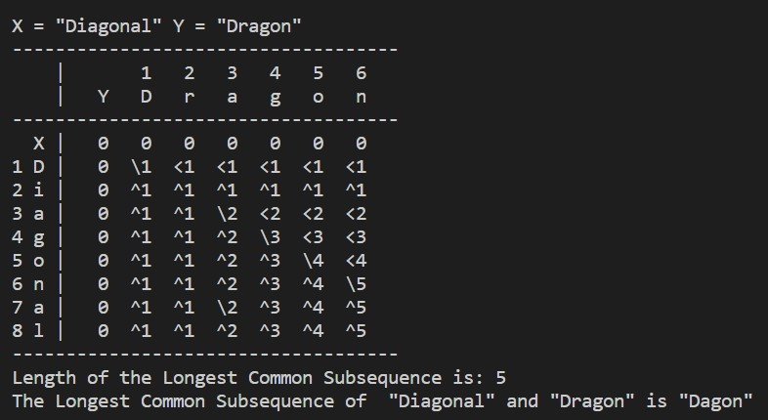

**For line 2:**

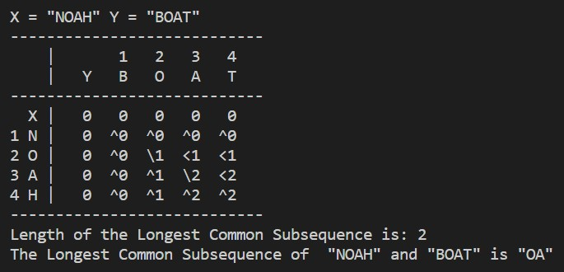

**For line 3:**

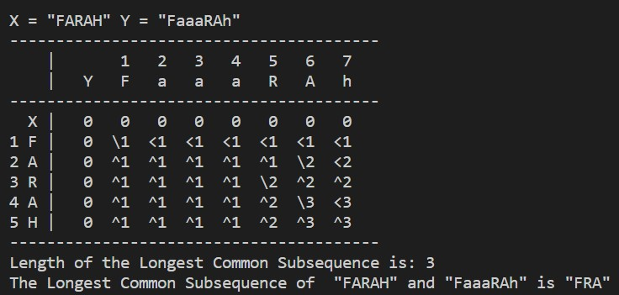

**For line 4:**

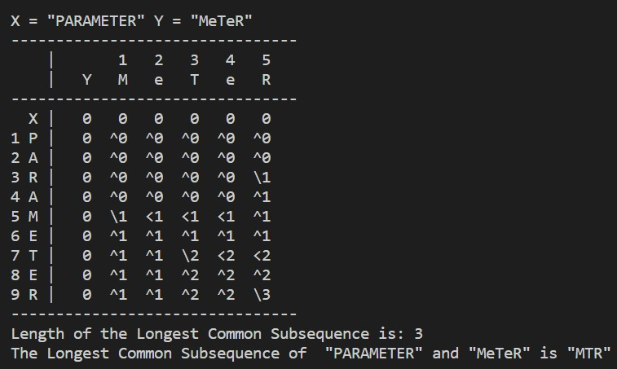

HONOR CODE

I pledge, on my honor, to uphold UT Arlington's tradition of academic integrity, a tradition that values hard work and   
honest effort in the pursuit of academic excellence.   
I promise that I will submit only work that I personally create or that I contribute to group collaborations, and I will   
appropriately reference any work from other sources. I will follow the highest standards of integrity and uphold the   
spirit of the Honor Code   
I will not participate in any form of cheating/sharing the questions/solutions.

JAY SHAH 1002070971 DATE: - 11/26/2022

## DEEP PATEL 1002052935 DATE: - 11/26/2022

